**Detailed Status of Recognition**

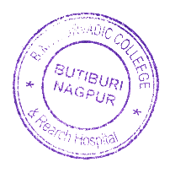Bhausaheb Mulak Ayurved College & Research Hospital Butibori is recognized by National Commission for Indian System of Medicine since 2017 and is affiliated with Maharashtra University of Health Sciences, Nasik for UG course with Intake capacity of 100 students.